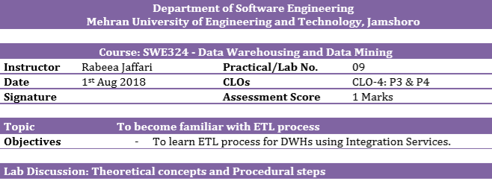
TASK : Lab1 dealt with extracted data from a single flat file source, transformed the data using Lookup transformations, and finally loaded the data into the FactCurrency fact table of the AdventureWorksDW2014 sample database. However, a typical ETL process would extract data from multiple flat file sources and you have to do so. The sample files can be downloaded from the link below:
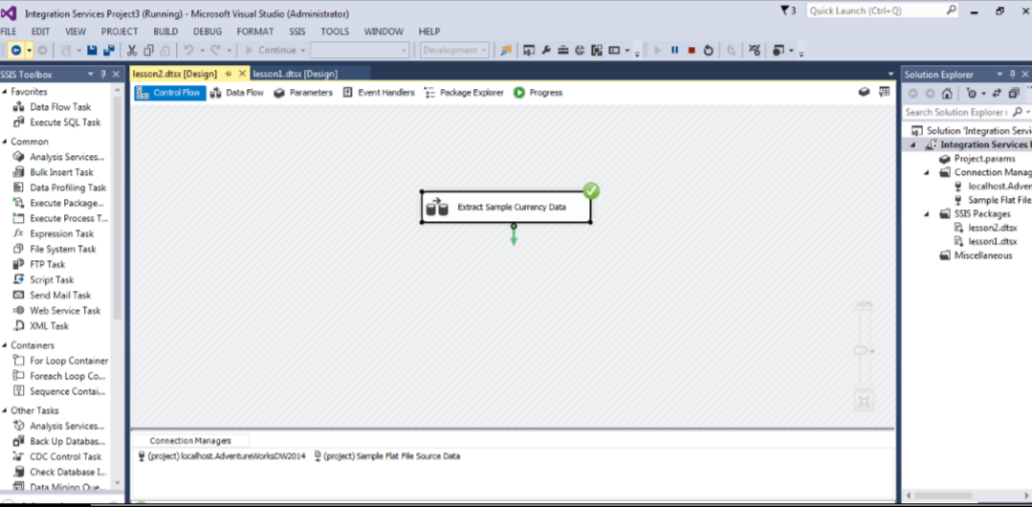

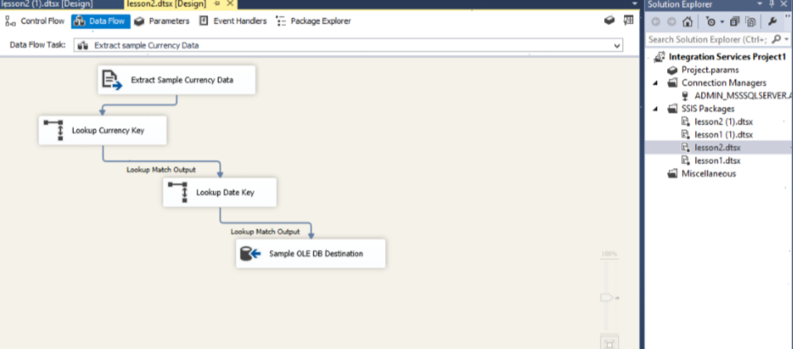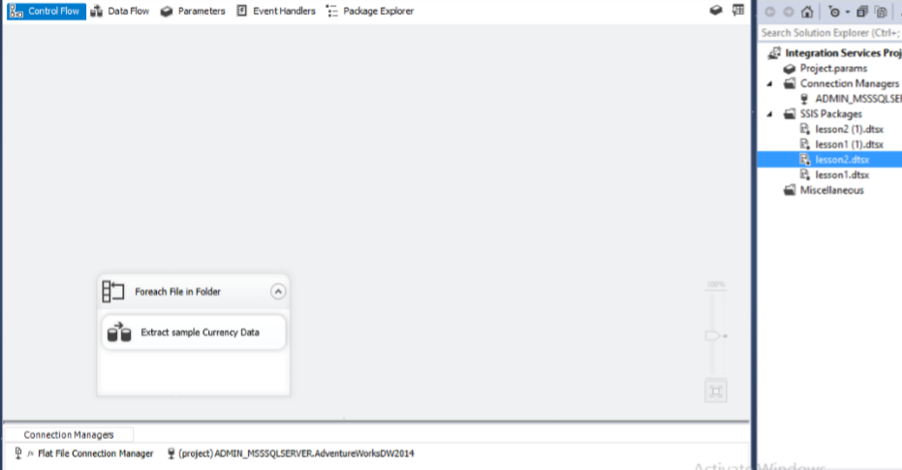

Class Task:”